AUTOMATED NETWORK REQUEST MANAGEMENT
Complete End-to-End ServiceNow Runtime Workflow
Implementation Evidence • Final Runtime State • 02 October 2026
This workflow documents the complete demonstrated runtime path of the project, including request submission, REQ/RITM creation, Flow Designer execution, operational record creation, approval, approved/rejected branching, final record state, notification evidence, and execution validation.

1. Complete Workflow Overview
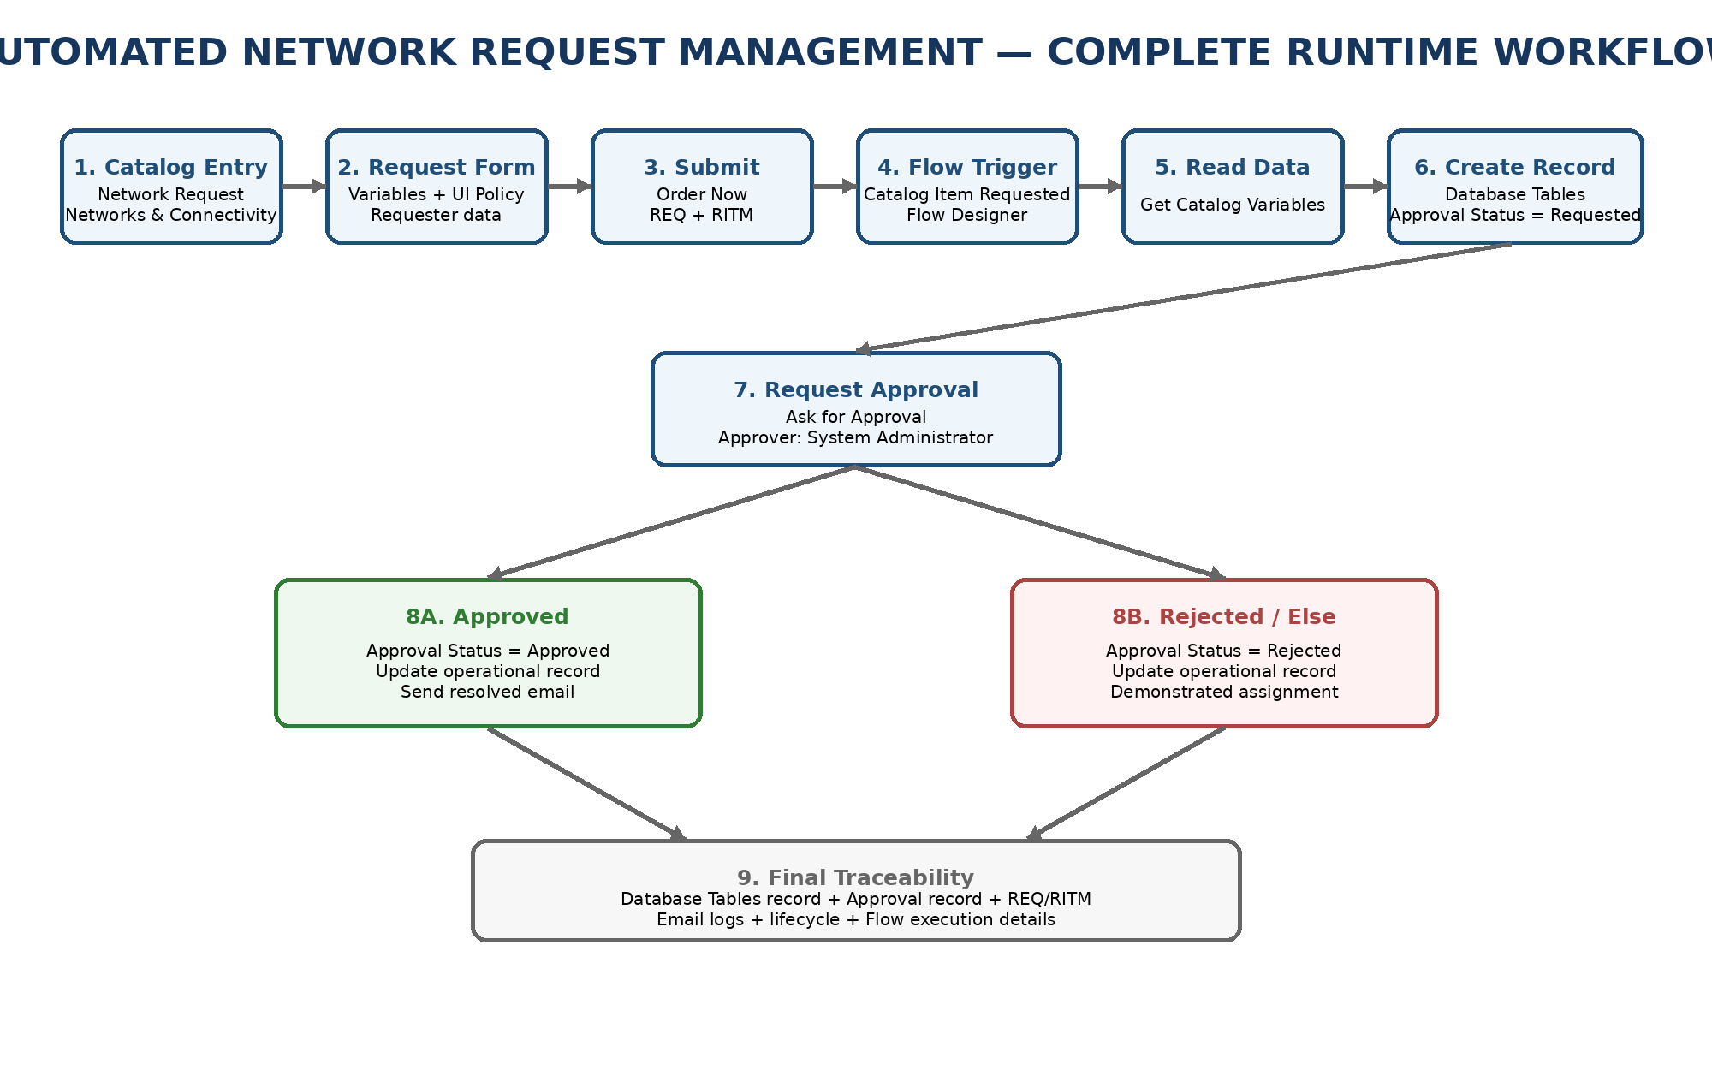
Figure 1. Complete end-to-end runtime workflow of Automated Network Request Management
The implementation is best understood as a sequence of connected ServiceNow events rather than as isolated configurations. The requester begins in Service Catalog; the submitted RITM triggers Flow Designer; the flow reads catalog data, creates the Database Tables operational record, sends notifications, requests approval, evaluates the approval result, updates the record, and produces final email and execution evidence.

2. End-to-End Stage Map
Stage | Phase | ServiceNow component | Purpose
1 | Catalog Entry | Service Catalog / Network Request | Open the Network Request item.
2 | Data Capture | Catalog Variables + UI Policy | Capture requester and request details.
3 | Submission | Service Catalog | Submit request and create REQ/RITM.
4 | Automation Trigger | Flow Designer | Catalog Item Requested starts the flow.
5 | Variable Retrieval | Get Catalog Variables | Read selected request variables.
6 | Operational Record | Database Tables | Create record; Approval Status starts as Requested.
7 | Initial Notification | Send Email | Send Request has been Created.
8 | Approval | Ask for Approval | Route approval to demonstrated approver.
9 | Decision | If Request is Approved | Evaluate approval state.
10A | Approved | Update Record + Send Email | Set Approved and send Request has been Resolved.
10B | Rejected | Else + Update Record | Set Rejected and apply demonstrated assignment.
11 | Final Evidence | Database/Approval/Email/Execution | Validate final state and workflow completion.

3. Phase A — Catalog Entry and Request Design

3.1 Open the Network Request Catalog Item
The request starts from Service Catalog → Networks and Connectivity → Network Request. The active catalog item is the business entry point for the workflow.
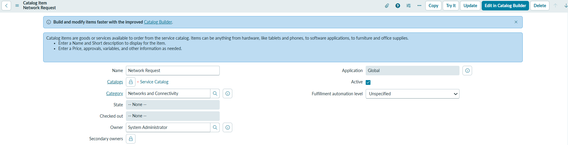
Figure 2. Network Request catalog item configuration

3.2 Configure the Request Variables
The implementation captures nine configured variables: Requested For, Mobile Number, Type of Connection, Enter your Existing ID, Total Amount, Mode of Payment, Address, Database Number, and Request Number.
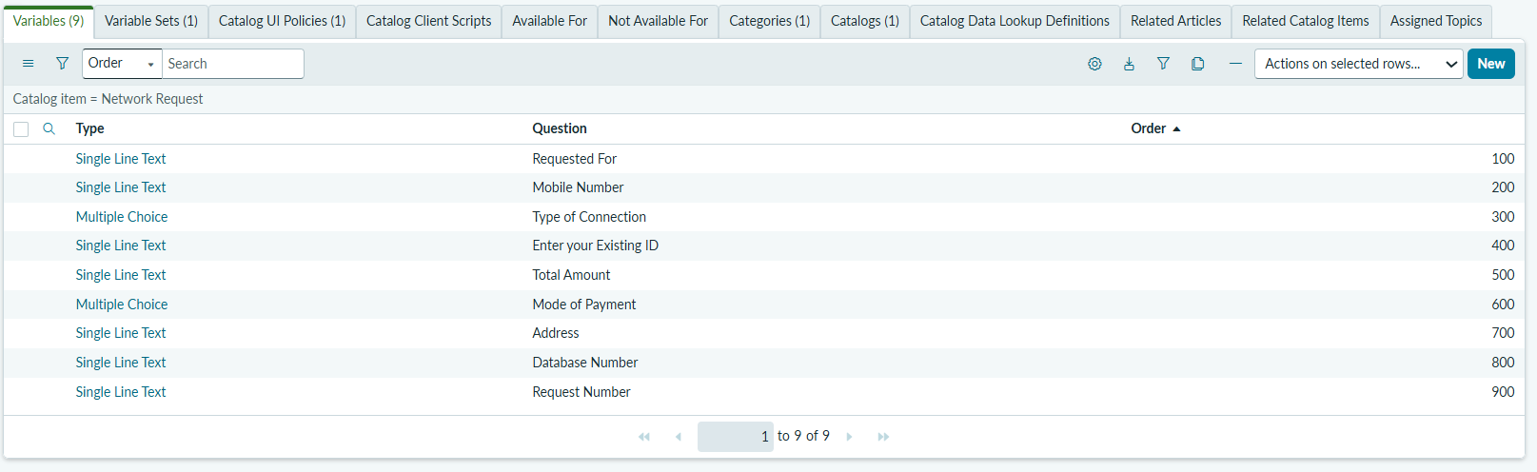
Figure 3. Network Request catalog variables

3.3 Apply Form Behaviour
The visible/hide of ID field Catalog UI Policy controls the form behaviour around the Existing ID field.
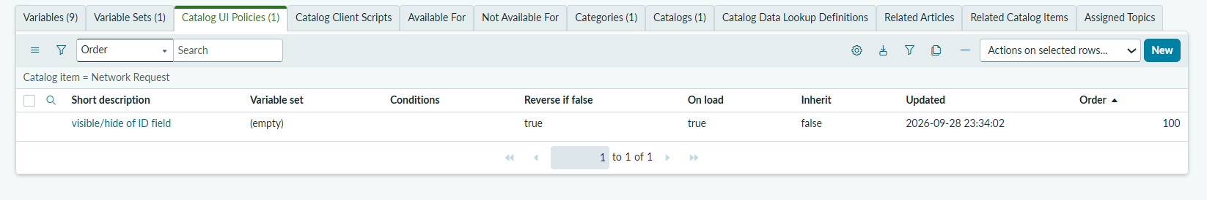
Figure 4. Catalog UI Policy

4. Phase B — Request Submission

4.1 Open the Request Form
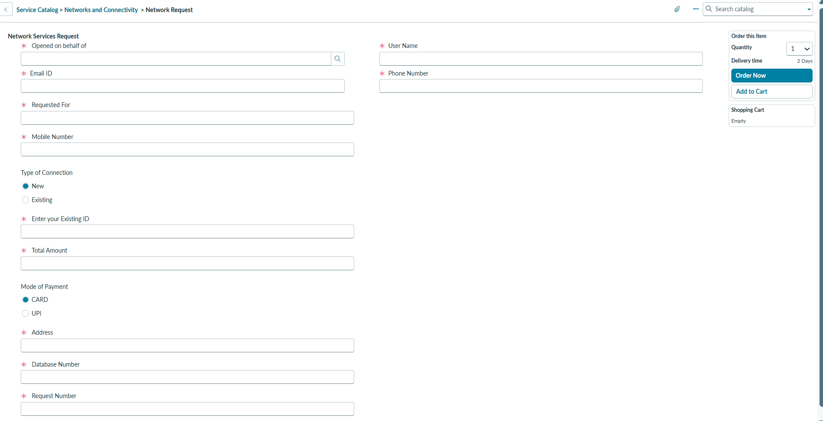
Figure 5. Network Request form before data entry

4.2 Enter Request Information
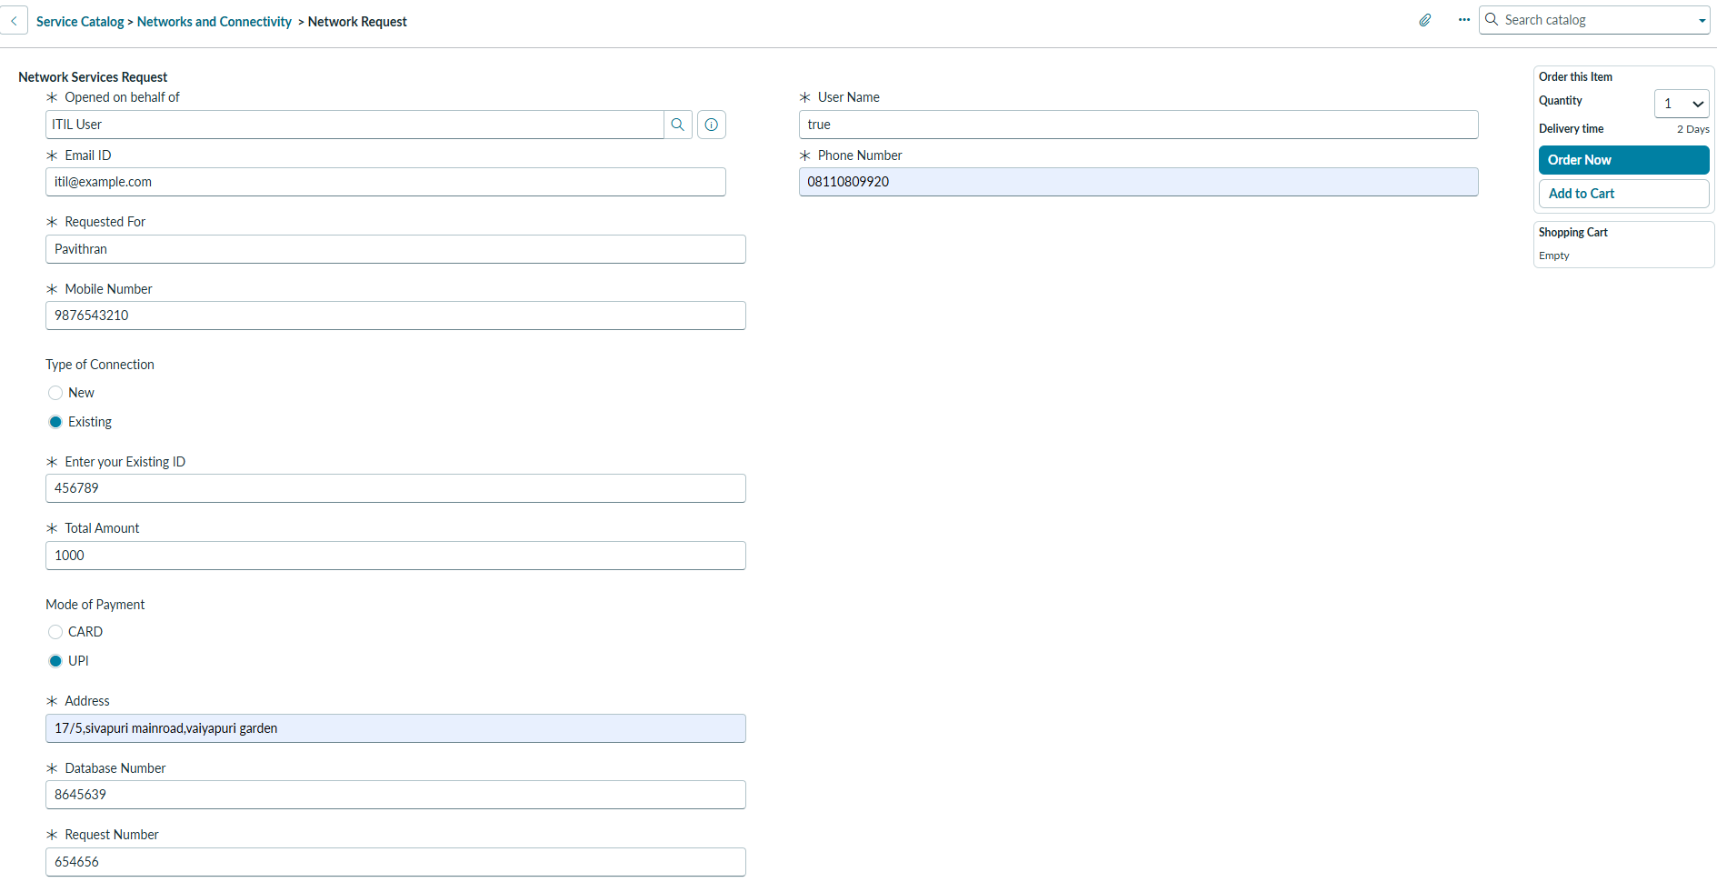
Figure 6. Completed Network Request form

4.3 Submit and Generate Request Records
Selecting Order Now submits the catalog item. The demonstrated transaction creates Request REQ0010014 and Requested Item RITM0010018.
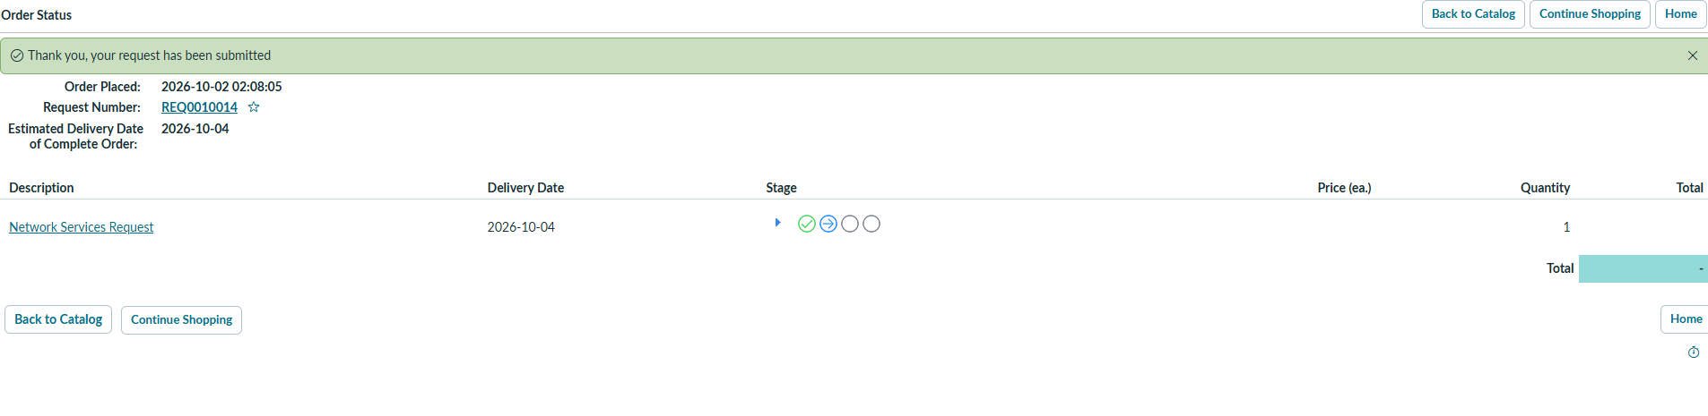
Figure 7. Order Status showing REQ0010014
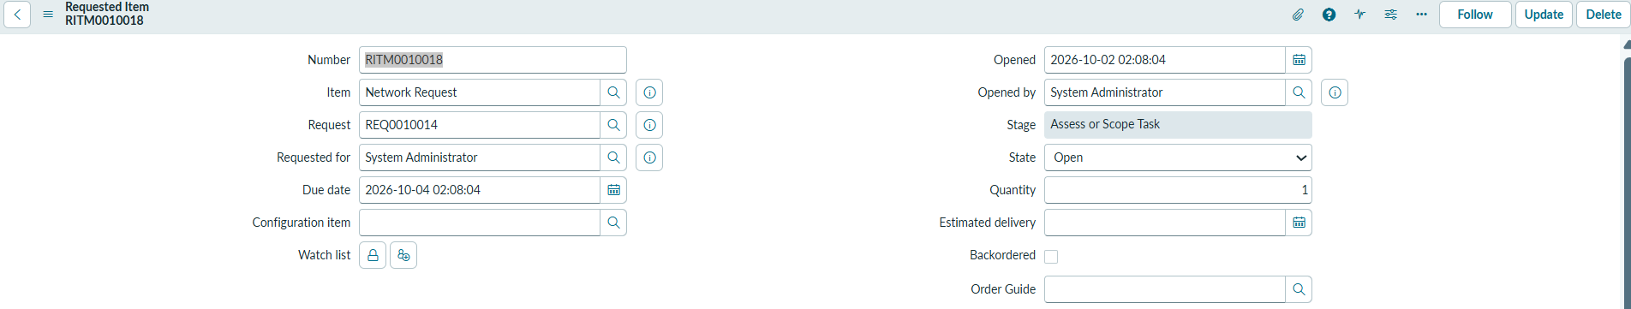
Figure 8. RITM0010018 associated with the Network Request

5. Phase C — Flow Designer Automation Starts
The submitted RITM becomes the input to the Network Request Flow Designer flow. The actual execution evidence later confirms that the Catalog Item Requested trigger ran successfully.
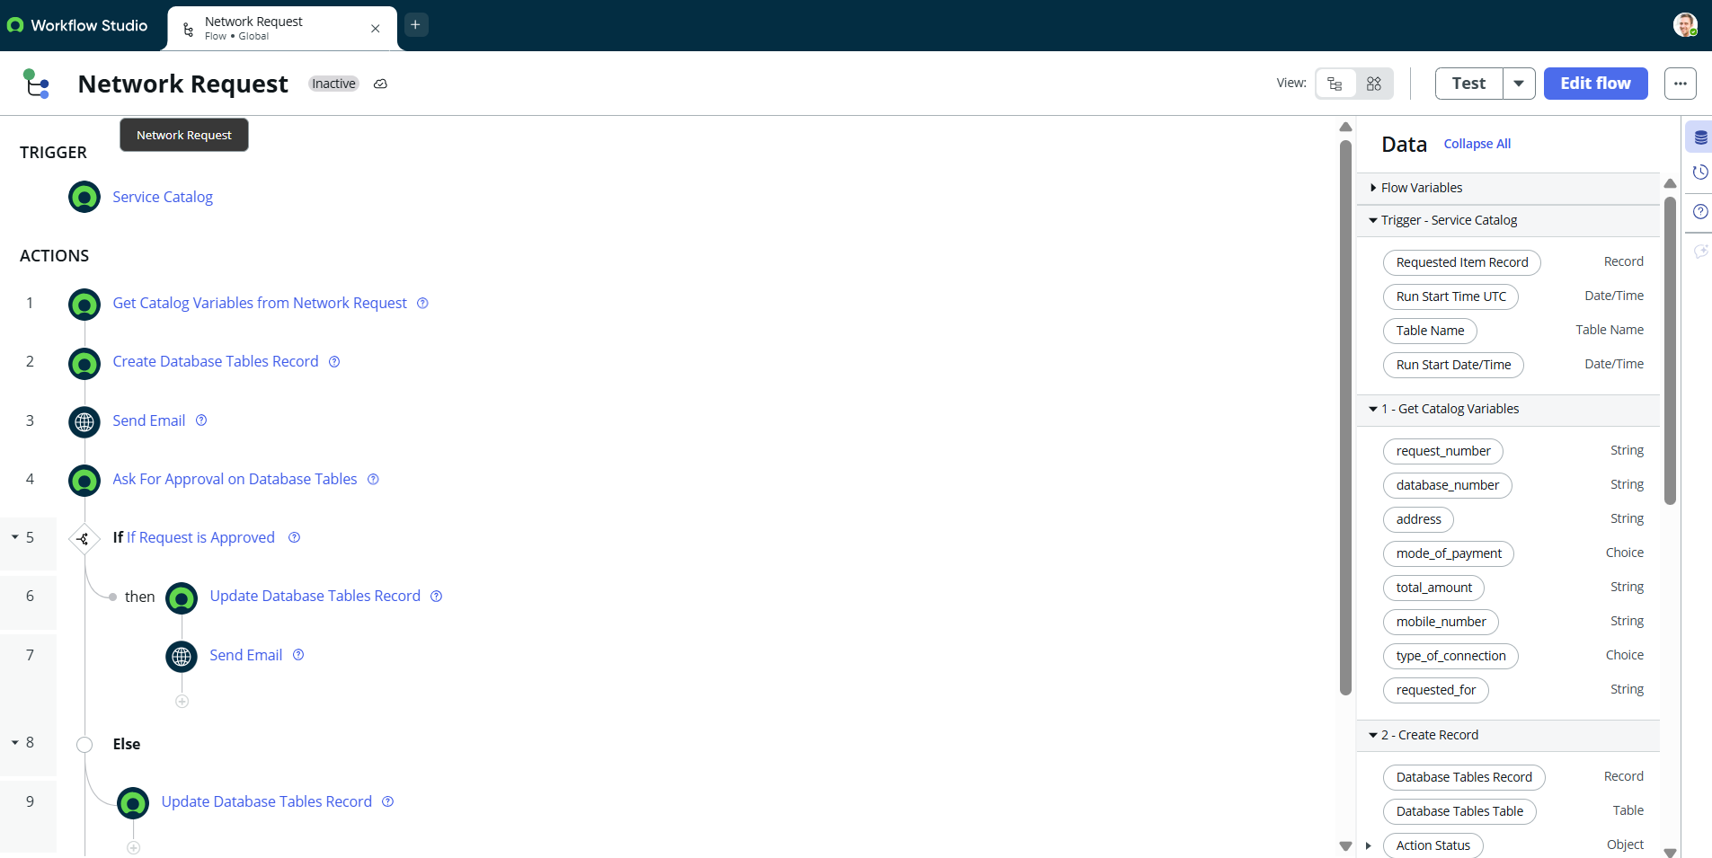
Figure 9. Network Request Flow Designer configuration

5.1 Get Catalog Variables
The flow retrieves the request_number, database_number, address, mode_of_payment, total_amount, mobile_number, type_of_connection, and requested_for values required by downstream actions.
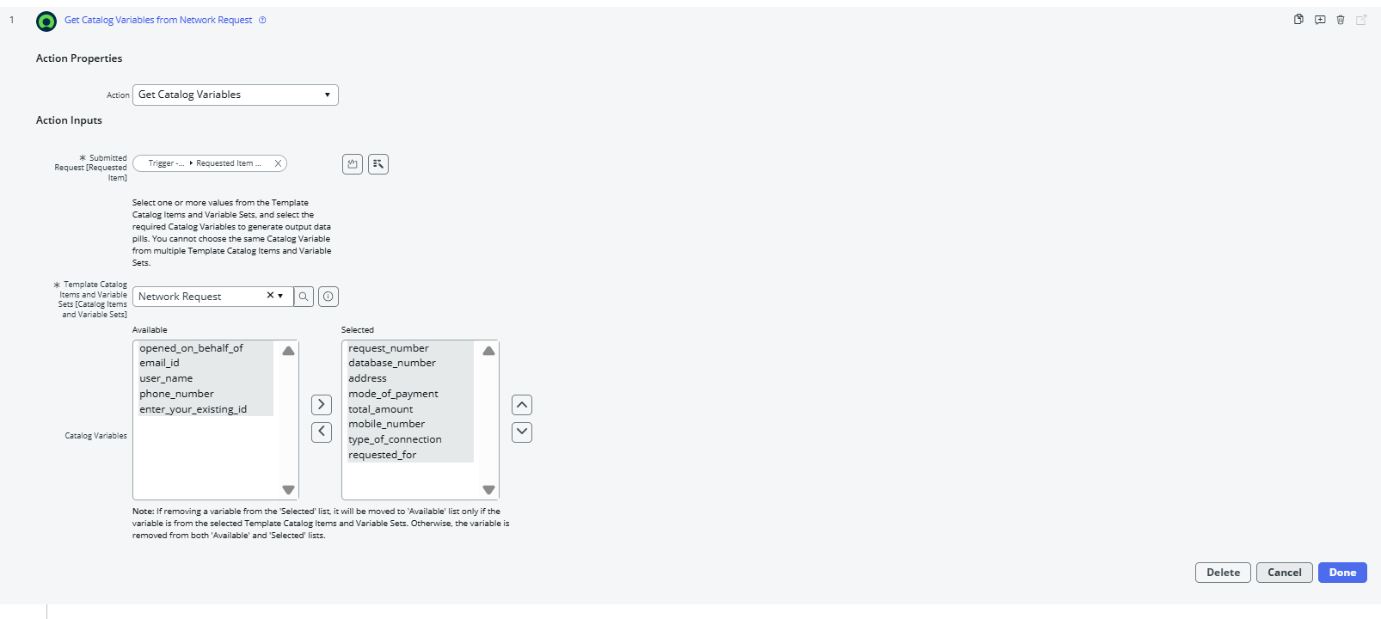
Figure 10. Get Catalog Variables action

6. Phase D — Database Tables Operational Record

6.1 Database Tables Structure
The implementation uses the custom operational table labelled Database Tables with technical name u_database_tables. This table is the target record structure for the automation.
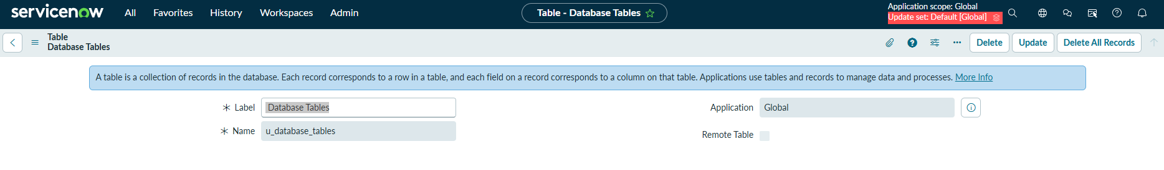
Figure 11. Database Tables custom table definition
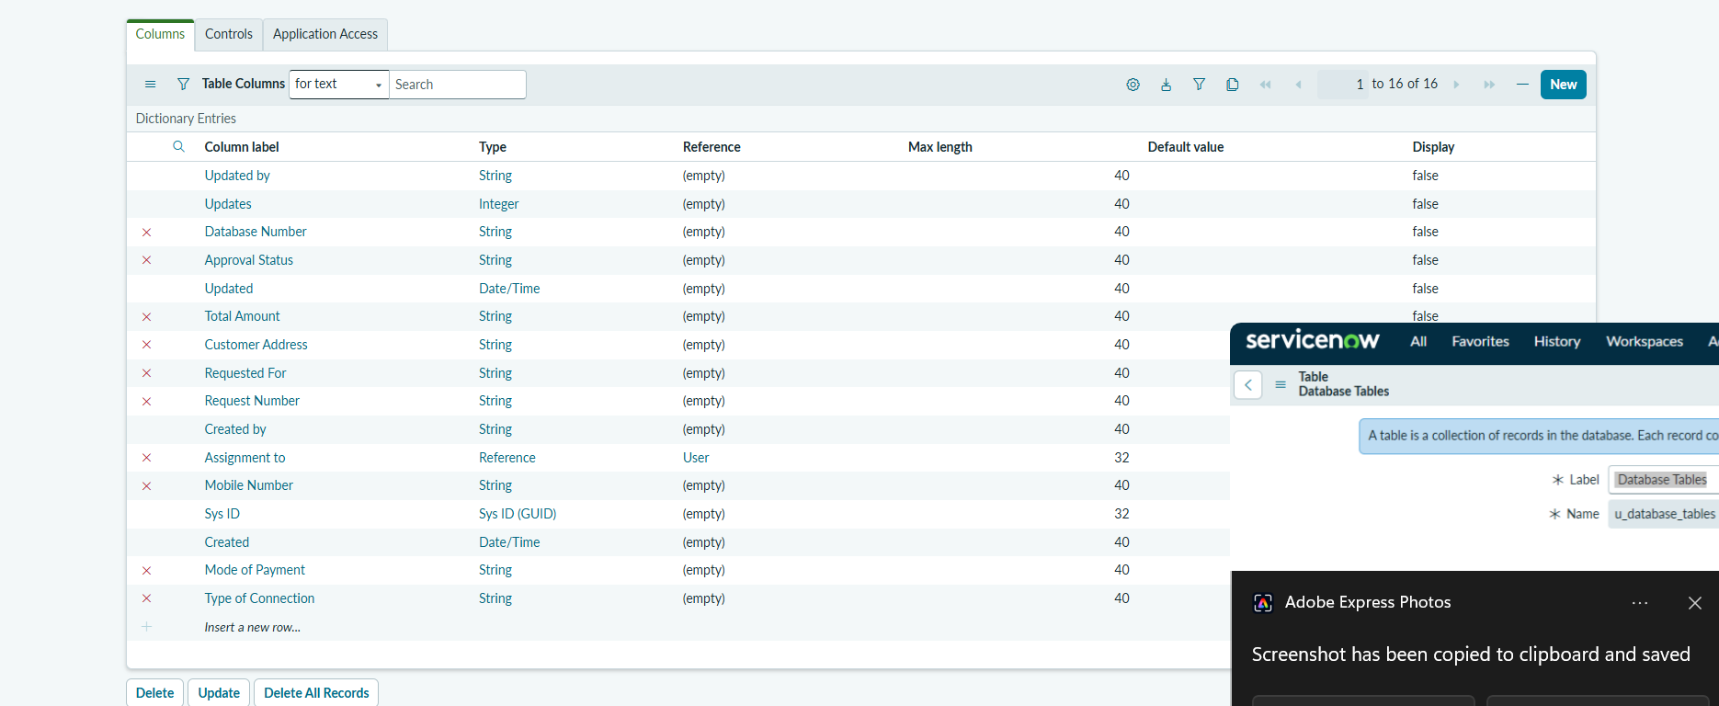
Figure 12. Database Tables field structure

6.2 Create the Operational Record
The Create Record action maps catalog values into the Database Tables record. Approval Status is initialized to Requested.
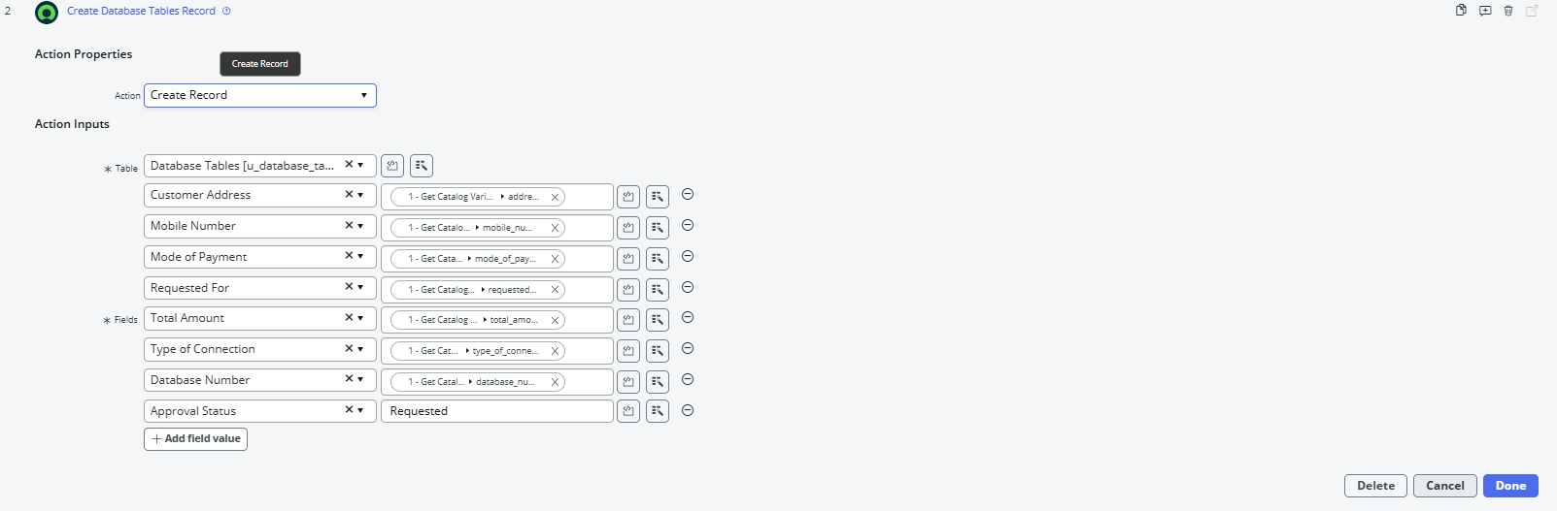
Figure 13. Create Record action and field mappings
The Database Tables record is not the same thing as the Service Catalog request itself: it is the configured operational record created by the flow from the submitted catalog data.

7. Phase E — Request-Created Notification
Once the operational record is created, the flow sends the initial acknowledgement with the subject Request has been Created.
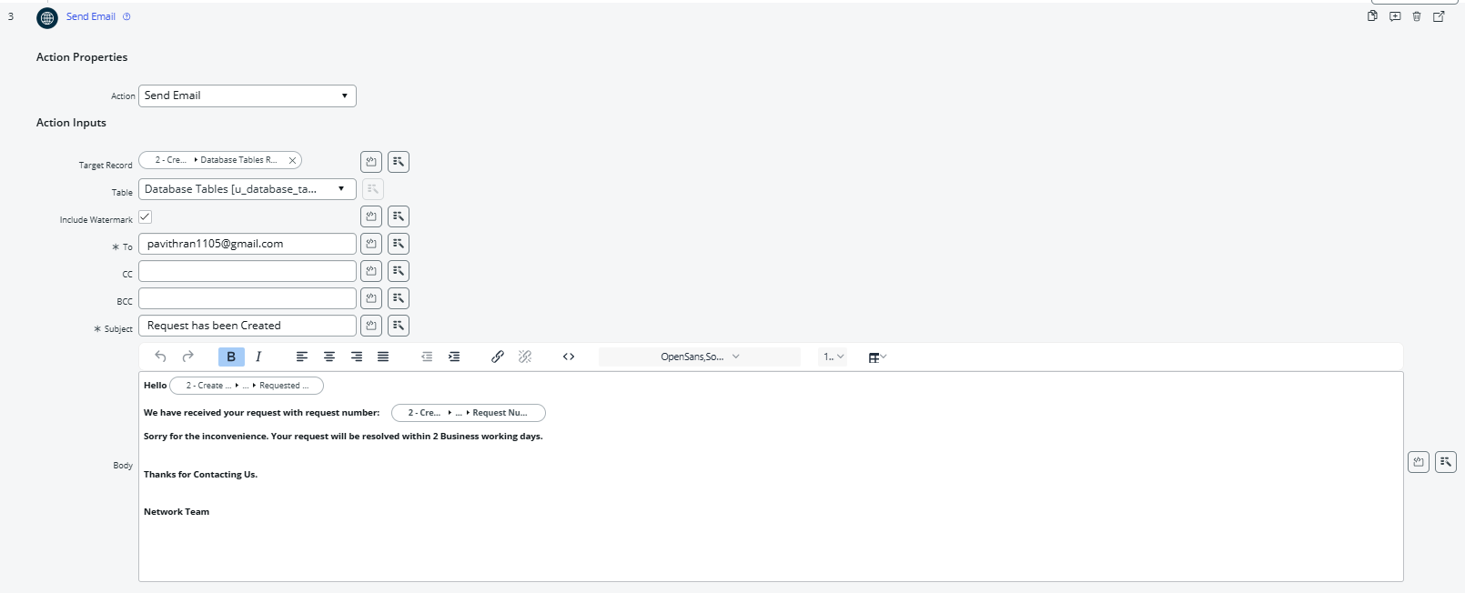
Figure 14. Request-created Send Email action
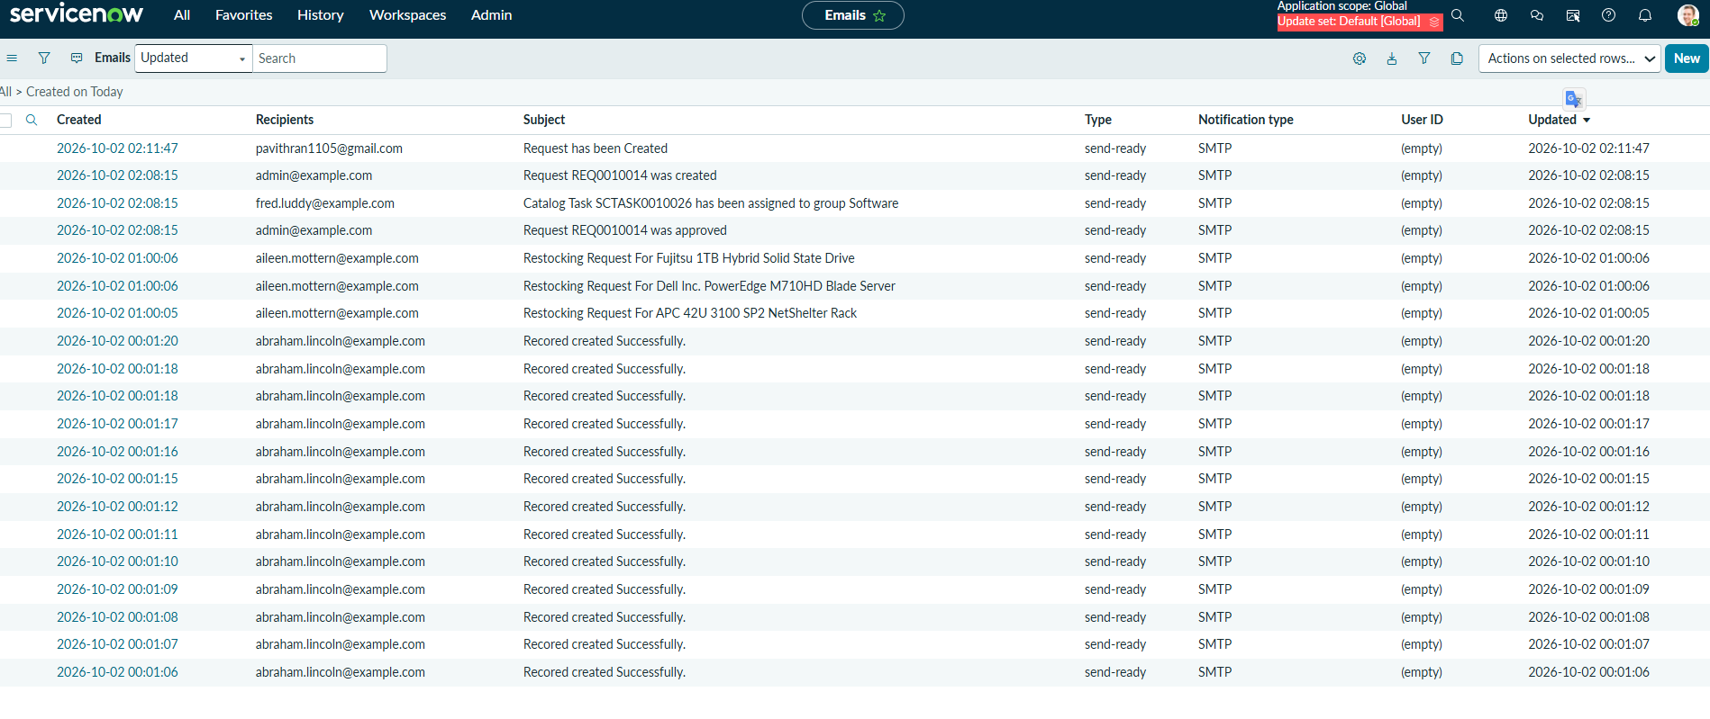
Figure 15. Email log showing Request has been Created
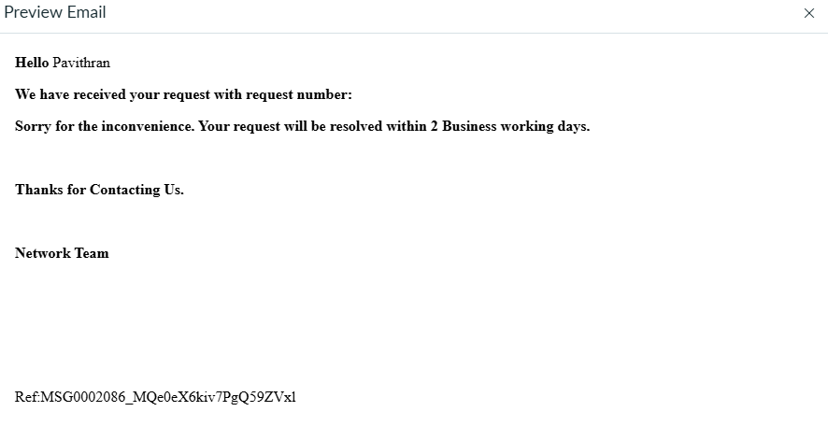
Figure 16. Preview of the request-created notification

8. Phase F — Approval Processing

8.1 Create Approval Request
The flow uses Ask for Approval on the Database Tables record. The demonstrated configuration uses Anyone approves and shows System Administrator as the approver.
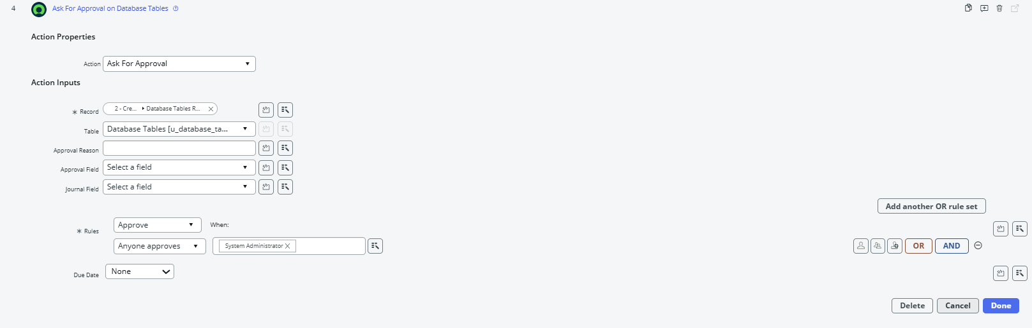
Figure 17. Ask for Approval action

8.2 Approval Record in Requested State
The created Database Tables record contains an Approval Request related list. The related approval initially appears in Requested state with System Administrator as approver.
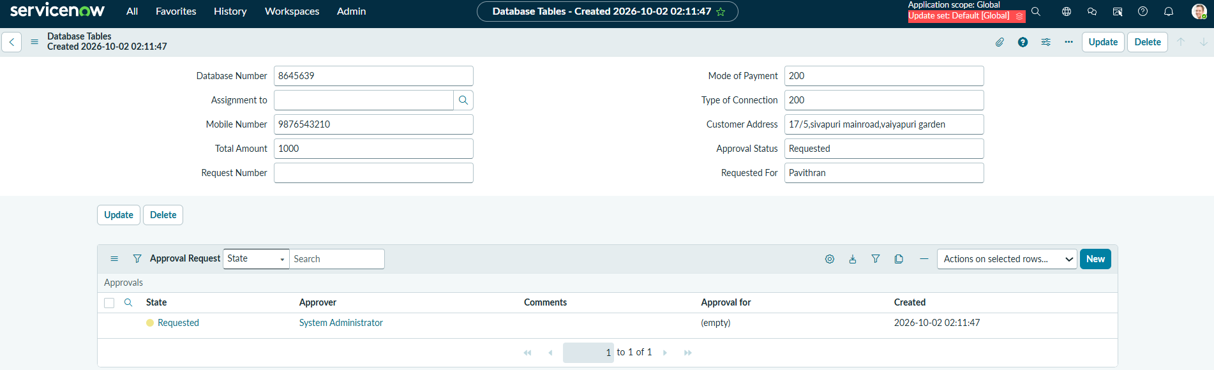
Figure 18. Database Tables record with approval request in Requested state
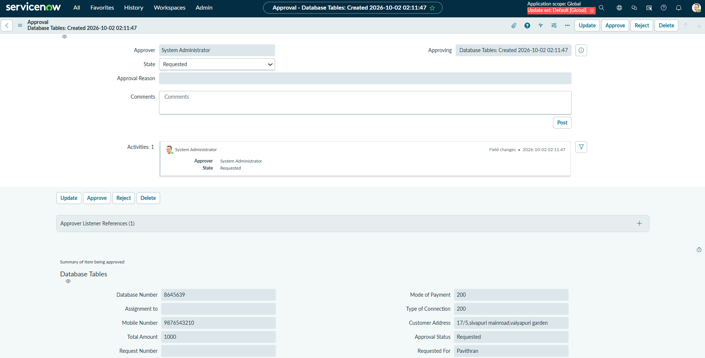
Figure 19. Approval record before decision

8.3 Evaluate Approval Result
The If condition checks whether the approval result is Approved. This is the control point that separates the successful approval path from the Else/rejected path.
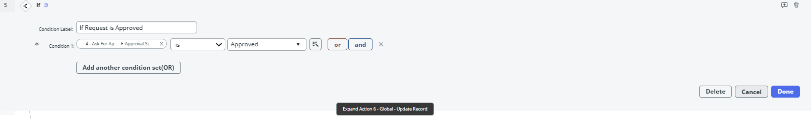
Figure 20. Approval decision condition

9. Phase G — Approved Path and Final Resolution

9.1 Approval Becomes Approved
The demonstrated approval is completed by the approver. The related approval list now shows Approved, and the Database Tables record shows Approval Status = Approved.
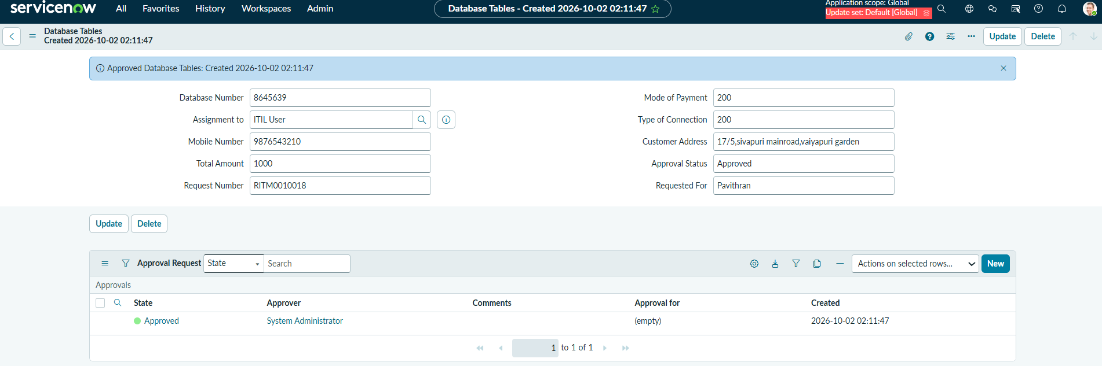
Figure 21. Database Tables record after approval

9.2 Approved Branch Updates the Record
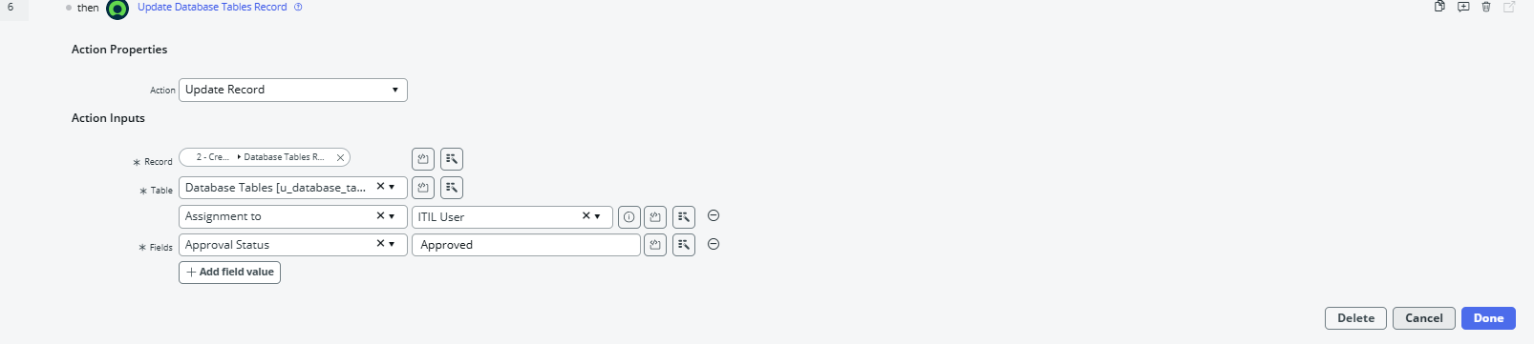
Figure 22. Approved branch Update Record action

9.3 Send Request-Resolved Notification
The approved branch executes the second Send Email action with the subject Request has been Resolved.
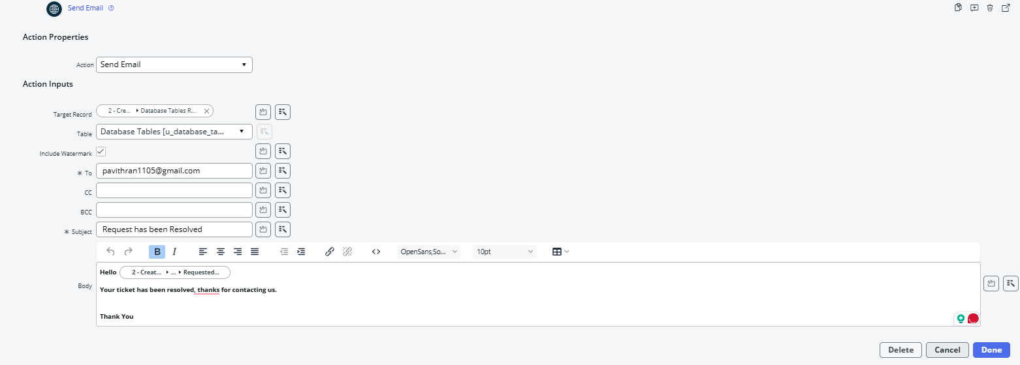
Figure 23. Request-resolved Send Email action

9.4 Verify the Resolution Email in the Email Log
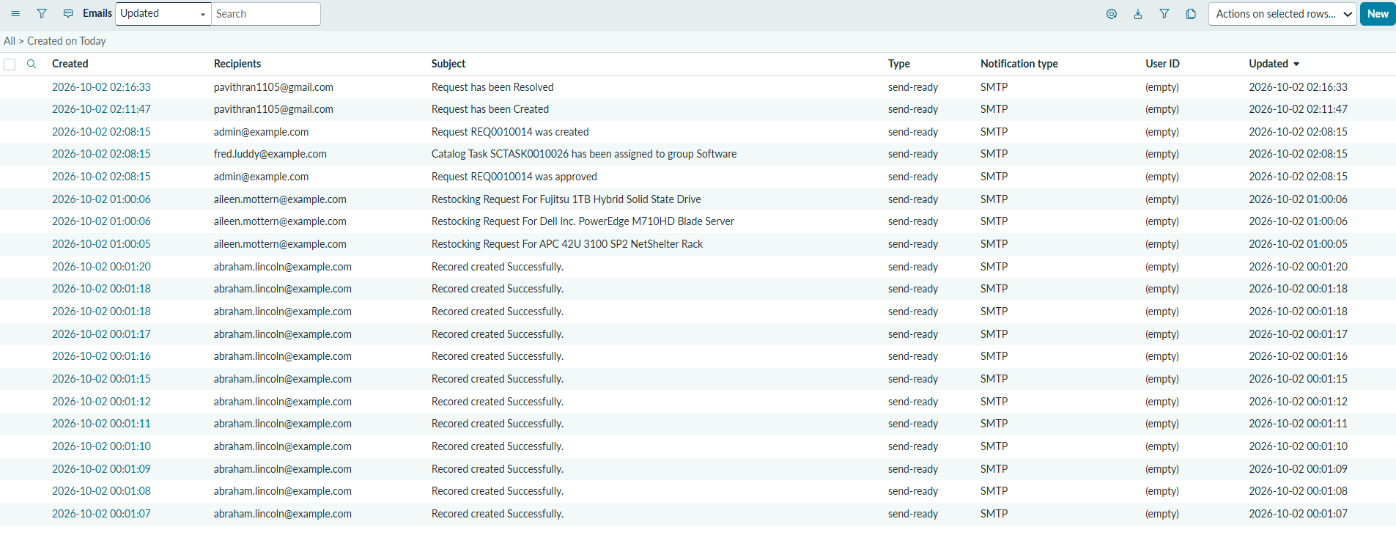
Figure 24. Email log showing Request has been Resolved
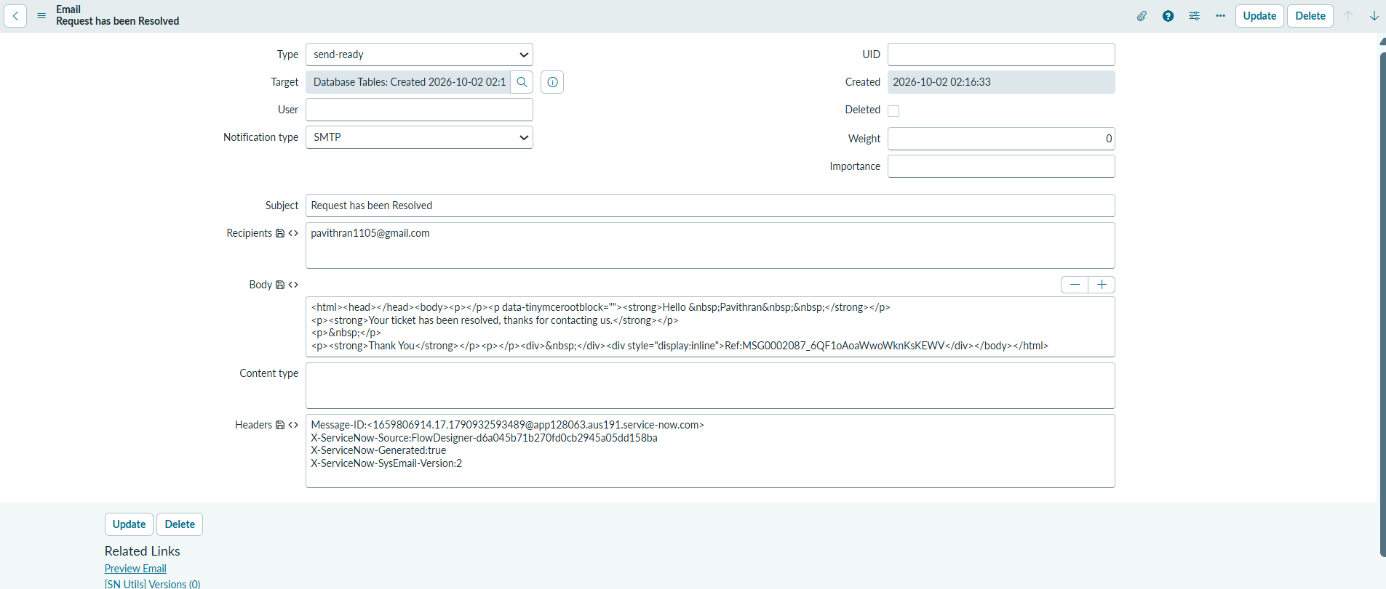
Figure 25. Request-resolved email record
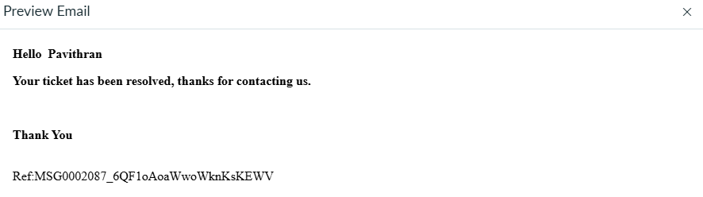
Figure 26. Preview of the request-resolved notification

10. Phase H — Rejected / Else Path
The workflow also contains an Else branch. If the approval condition is not satisfied, the flow updates the operational record with Approval Status = Rejected and the demonstrated Assignment to value.
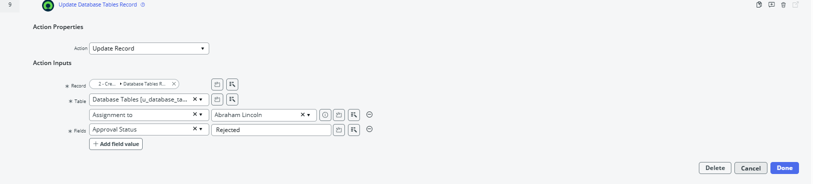
Figure 27. Rejected / Else branch Update Record action
In the final demonstrated run, the approval condition evaluated True, so the Else branch was not executed. It remains part of the configured workflow for the alternate outcome.

11. Phase I — Final Flow Execution Validation
The strongest final evidence is the Flow Designer Execution Details screen. The demonstrated run is Completed, with the Catalog Item Requested trigger completed, Get Catalog Variables completed, Create Record completed, Send Email completed, Ask for Approval completed, the approval condition evaluated True, Update Record completed, and the resolved Send Email completed. The Else branch is shown as Not Run because the request was approved.
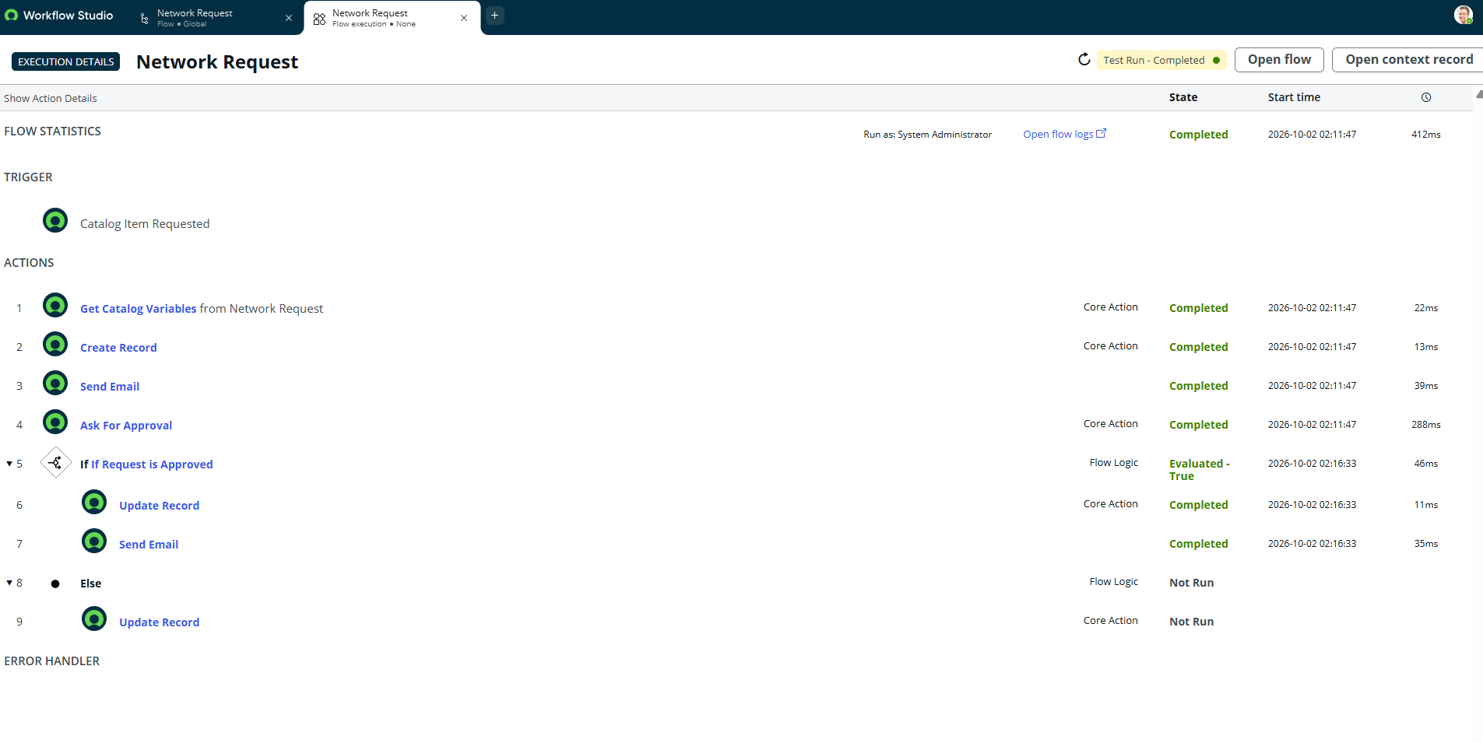
Figure 28. Completed Network Request Flow execution details

12. Phase J — Final Request Tracking and Operational Traceability
The final solution provides traceability across multiple ServiceNow records: the original REQ/RITM, the Database Tables operational record, the Approval Request record, email logs, and Flow Designer execution details.
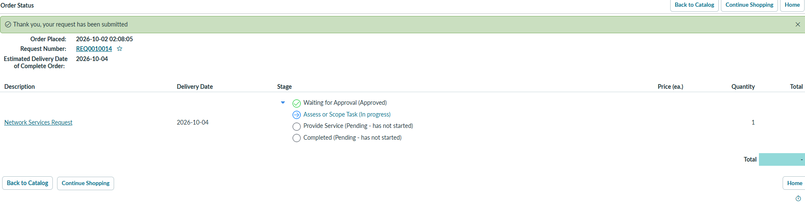
Figure 29. Request lifecycle / status visibility
The custom operational table also has record-level ACLs for create, write, read, and delete, supporting controlled access to the operational data.
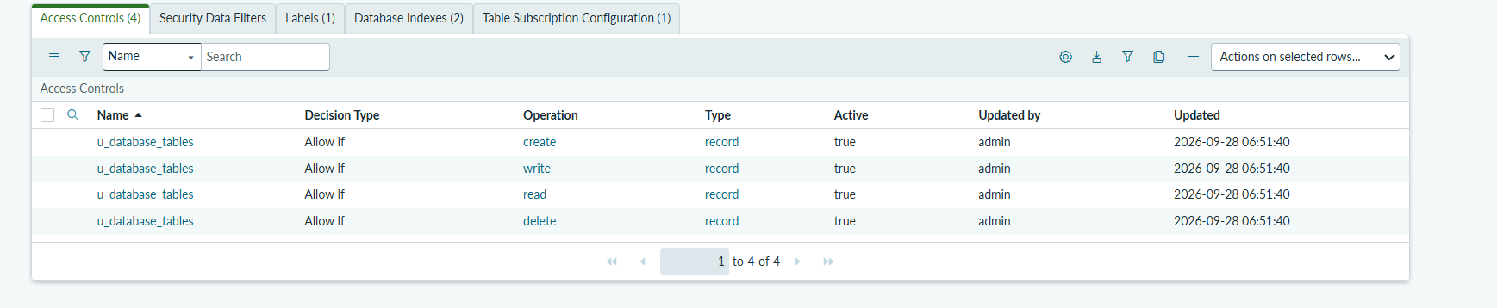
Figure 30. Active ACLs for the Database Tables operational table
The Approval Request relationship provides a direct trace from the Database Tables record to its approval records.
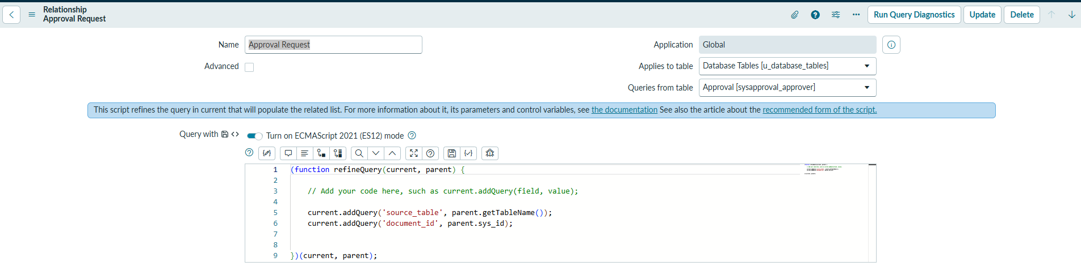
Figure 31. Approval Request relationship

13. Final End-to-End Runtime Sequence
The project is complete when the following chain has been demonstrated and validated:
1. User opens Network Request from Service Catalog.
2. User completes the structured Network Request form.
3. User submits the request through Order Now.
4. ServiceNow creates REQ0010014 and RITM0010018 in the demonstrated transaction.
5. Catalog Item Requested triggers the Network Request Flow Designer flow.
6. Get Catalog Variables retrieves the submitted request values.
7. Create Record creates the Database Tables operational record with Approval Status = Requested.
8. Request-created email is generated and visible in the email log.
9. Ask for Approval creates an approval request for the demonstrated approver.
10. Approval changes from Requested to Approved in the demonstrated successful path.
11. The approval condition evaluates True.
12. The approved branch updates the Database Tables record to Approved.
13. The flow sends Request has been Resolved.
14. The resolved email is visible in the email log and preview.
15. Flow execution details show the successful actions as Completed and the Else branch as Not Run.
16. REQ/RITM lifecycle and related records provide final traceability.

14. Final Implementation Boundary
This document describes only the behavior demonstrated by the supplied ServiceNow evidence. The implemented workflow does not claim direct network-device configuration, external network APIs, Power BI reporting, AI/ML decision-making, payment gateway integration, or external messaging integrations.
Important implementation terminology is preserved: the project is presented as Automated Network Request Management, while the actual configured operational table is retained as Database Tables / u_database_tables and the demonstrated request artifacts retain their actual REQ/RITM identifiers.

15. Demonstration Narration — Final Version
- “We begin with the Network Request catalog item under Networks and Connectivity.”
- “The requester completes the structured form and submits it, generating the REQ and RITM.”
- “The Service Catalog trigger starts the Network Request Flow Designer flow.”
- “The flow retrieves the catalog variables and creates the Database Tables operational record.”
- “The workflow sends a request-created acknowledgement and then creates an approval request.”
- “Once the approver approves the request, the approval condition evaluates true.”
- “The approved branch updates the operational record to Approved and sends the Request has been Resolved notification.”
- “We verify the resolved email, the completed Flow Designer execution, and the final request/lifecycle evidence.”
- “The Else branch is also configured for rejection, but it is not executed in this successful demonstration.”

